INDEX
- History of wireless…………………………………….…2.
- A brief view of Anurag FM……………………….…..…4.
- Circuit description………………………………………..4.
- Usage of filters………………………………………..…..8.
- Usage of feedback Amp…….…………………………......9.
- Generation of voice signal…………………………..........11.
- Brief view of microphone……….......................................12.
- Design of FM Tower………………..................................13.
- Features…………………………………………………..14.
- Trouble shooting………………………………………….15.
- Block diagram….………………………………………...17.
- purpose………..………………………………………….18.
- conclusion…..……………………………………………20.
- Bibliography…..…..………………………………..……21.

Brief History of Wireless Communications:
Before the ``Birth of Radio'', 1867-1896
- *1867 - Maxwell predicts existence of electromagnetic (EM) waves
- *1887 - Hertz proves existence of EM waves; first spark transmitter generates a spark in a receiver several meters away
- 1890 - Branly develops coherer for detecting radio waves
- 1896 - Guglielmo Marconi demonstrates wireless telegraph to English telegraph office
``The Birth of Radio''

- *1897 - ``The Birth of Radio'' - Marconi awarded patent for wireless telegraph
- 1897 - First ``Marconi station'' established on Needles island to communicate with English coast
- 1898 - Marconi awarded English patent no. 7777 for tuned communication
- 1898 - Wireless telegraphic connection between England and France established

Transoceanic Communication
- *1901 - Marconi successfully transmits radio signal across Atlantic Ocean from
Cornwall to Newfoundland
- 1902 - First bidirectional communication across Atlantic
- 1909 - Marconi awarded Nobel prize for physics

Voice over Radio
- *1914 - First voice over radio transmission
- 1920s - Mobile receivers installed in police cars in Detroit
- 1930s - Mobile transmitters developed; radio equipment occupied most of police car trunk
- *1935 - Frequency modulation (FM) demonstrated by Edwin H.Armstrong
- 1940s - Majority of police systems converted to FM

A brief view of 96.4MHZ Anurag FM (DTS).
(With u… for you …for ever…)

FM modulation and broadcasting:

Here we discuss about the college radio i.e., AFM (dts) direct to student. It deals with the transmitting service provided by the college management. Here the internal block diagrams and circuit diagrams of the FM modulation are shown in the following figures.
VHF oscillator
Class-C Driver
Class-C Amplifier
MIC

Here the 3-stage R/F sections are used
  - A variable frequency V.H.F oscillator.
  - A Class-C R/F driver
  - Class-C R/F amplifier with harmonic filterHere for this circuit we can give power supply as 9 to 12 volts.

Circuit Description:

Here the circuit can produce R/F o/p power of 150mw can be transmitted through telescopic antenna of 75cm length. We can extend this range of the radiation using yagi antenna by the three elements dipole, reflector, director’s.but it can extend the range in uni direction. Here the circuit diagram of mother board or R/F board is shown following figure.

- The frequency of transmitter can be set with in 88-108 MHz of FM band by adjusting the first trimmer
- Here we eliminate the noise and set the maximum range by adjusting the 2nd & 3rd trimmers.
- Here totally 3-transisters are used those are BEL-548, and 2-C-2570 transistors, the 548 transistor can boost the signal coming from the microphone i.e., it can work as pre-amp to the microphone. Here by using this transistor o/p is multiplied with carrier generated by the C-2570 via a capacitor.

- Here C-2570 is class-c amp is having good capability to drive V.H.F range of signals and is used to generate the non linear waveforms i.e., it generates V.H.F. oscillations, based on the biasing we can use it as class-C amp. Herein class c Q-point is set well beyond cutoff and the device conducts for less than 180⁰.The conversion efficiency can theoretically reach 100%.
- The transfer curve is given as follows

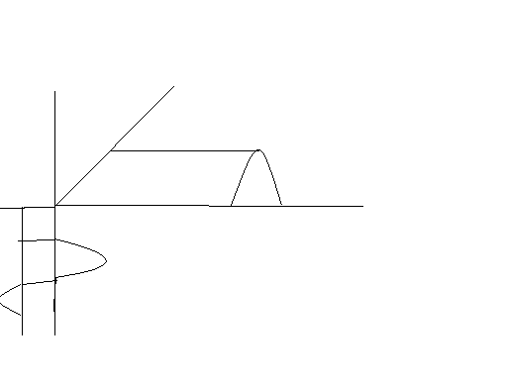
α1
α2
α1
α2
Q
I_{c}
V_{be}
0
∏∏

- Here the maintenance of the S/N ratio is improved by adjusting the trimmers.

- We just know how oscillations are generated? The generating mechanism of oscillations is mainly due to non linear waveforms generated by the transistor.
I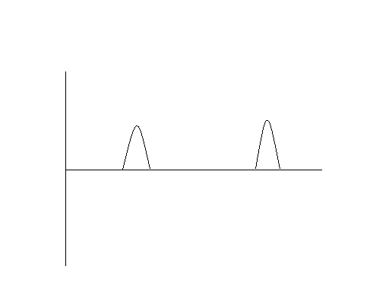
0
∏
2∏
3∏
V_{be}
I_{c}
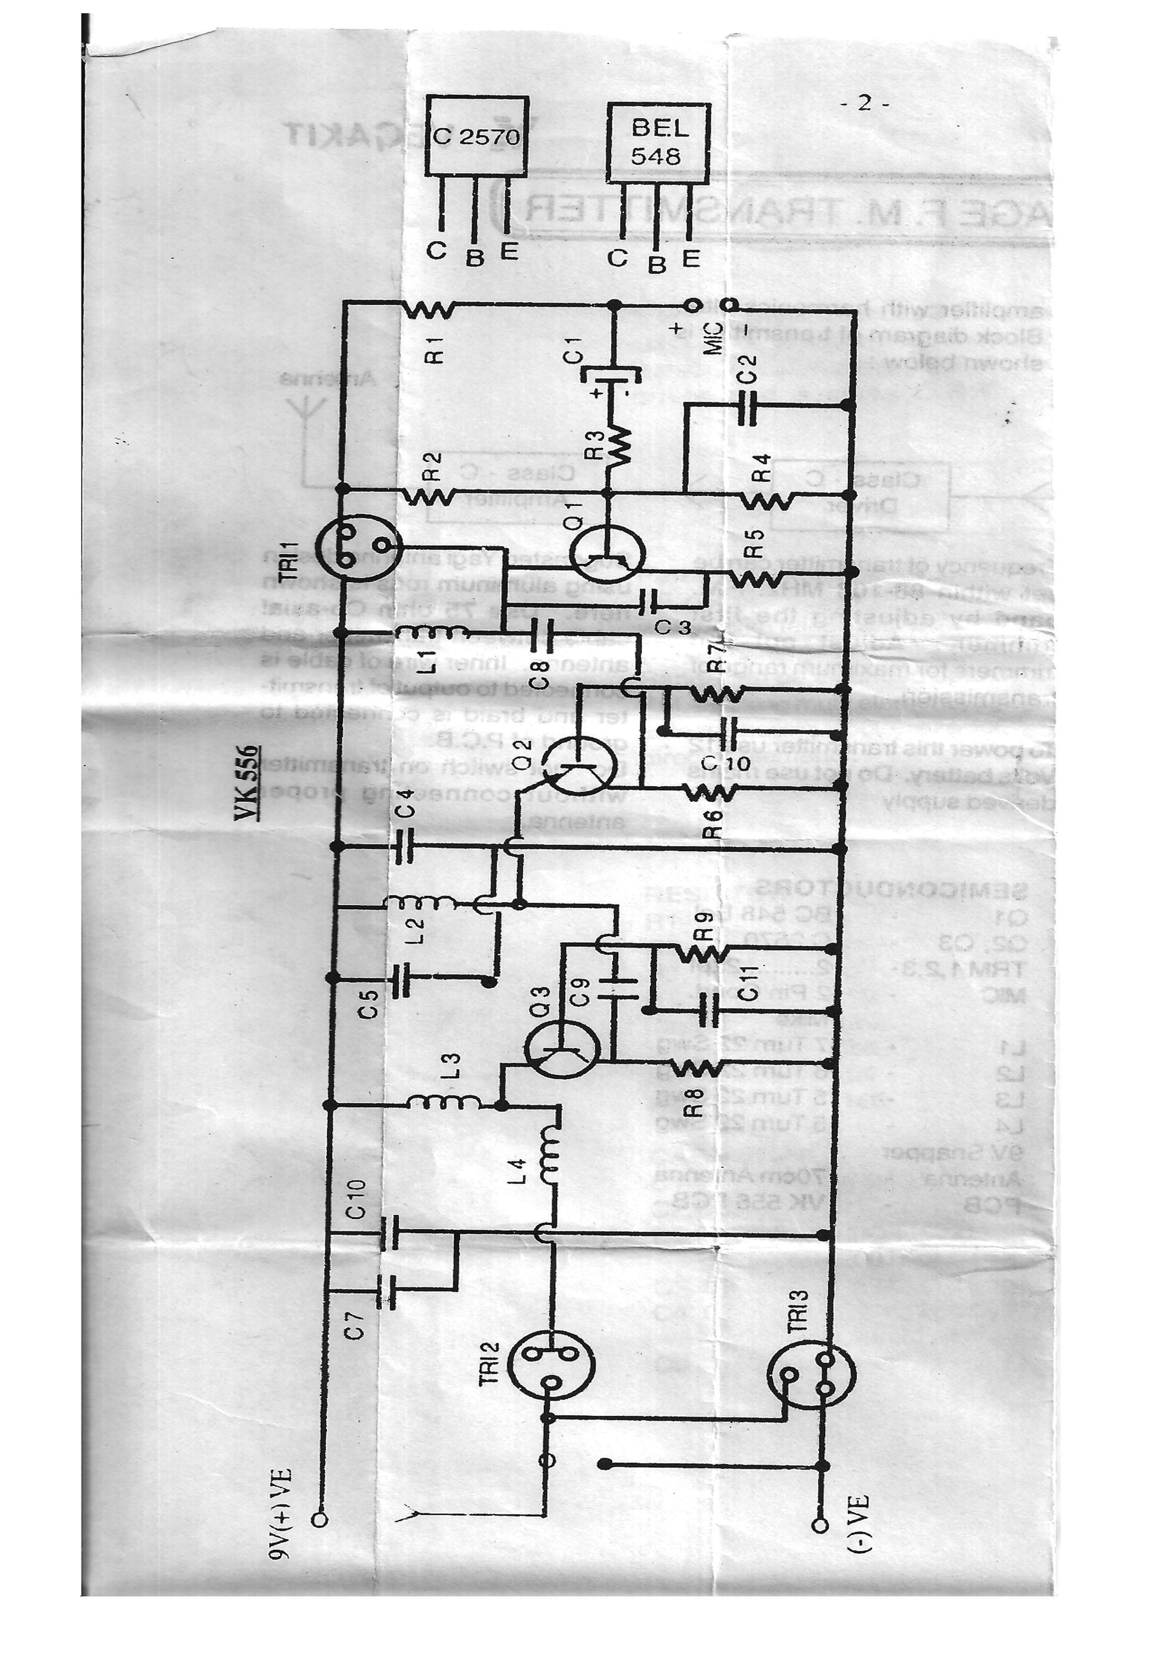

Here the main circuit is operated with voltage source i.e., frequency mainly depends on the voltage i.e., if any voltage fluctuation occurs the frequency may varies, it is working on the basis of V.C.O. i.e., voltage control oscillator.

- Here the entire frequency i.e., a.c.signal will be decided by D.C.

- Here the entire circuit is having only one i/p signal so in order to use more i/p signals i.e., voice signal and audio signals fed from a system are DVD players we use an impedance matching n/w.

Usage of Filters:

- Here there are two impedance matching n/w’s one is for high pass filter to allow highest frequency of the audio signal i.e., it provides only a treable sound.
- Another filter is all pass filter it can allow entire range of the audio signal i.e., 20Hz to 20KHz.so in -this range we can send a song is having of highest frequency 20KHz which is having a treable component, and lowest frequency 20Hz which is having a Bass component of sound and as well as we can send voice range of 300Hz to 3KHz.so for this purpose only the FM is more useful so that the variation of the audio frequency amplitude levels are avoided in FM.

- So here with these two filters we can work with the i/p signals for selecting the voice and background music for a radio station generally.

Usage of feedback Amp:

- So in order to keep the power and frequency as constant to avoid unwanted noises generated by trimmers and inductors we use a feed back amp.

- Here is a negative feed back amp it provides R/F gain is constant, and its amplitude does not improve but almost it maintains unity.

- Here the circuit view of feedback amp is shown in following figure.
- . The main purpose of the feed back amp is it can provide impedance matching to the load i.e., the load is Antenna/Power Amp.
- Here the o/p from this feed back Amp is connected to the power amp which can produce a power of 15Watts used for a single block from 100 to 300 mts of distance.
- We can extend the range of the radiation by using power amp with high power or we can change the dimensions of the Antenna and made to use a Yagi Antenna we can extend up to 15Kms in uni direction
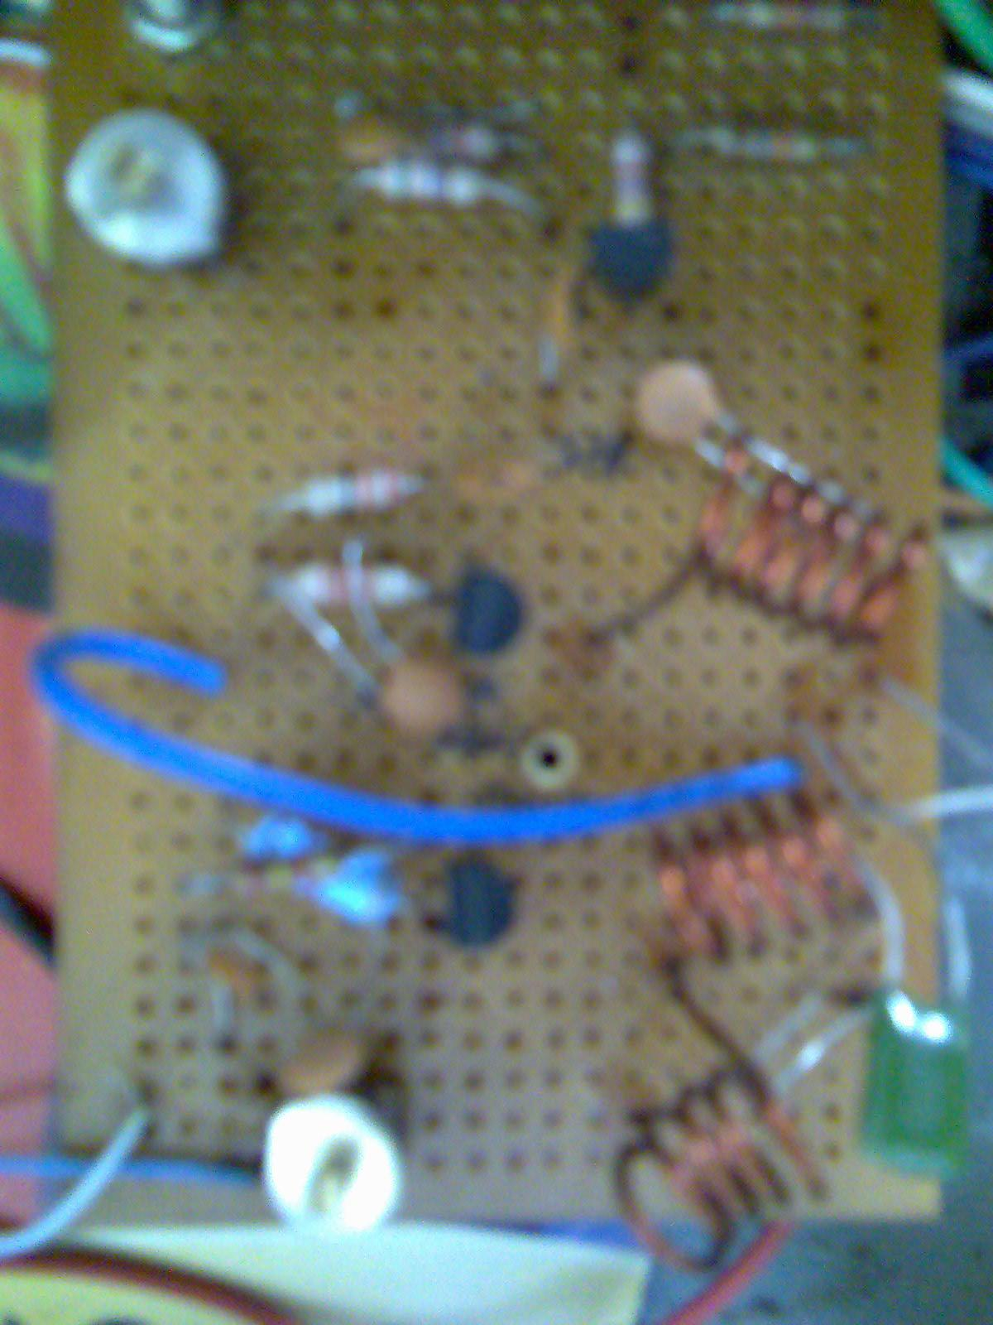
- Here the o/p from this feed back Amp is connected to the power amp which can produce a power of 15Watts used for a single block from 100 to 300 mts of distance.
- We can extend the range of the radiation by using power amp with high power or we can change the dimensions of the Antenna and made to use a Yagi Antenna we can extend up to 15Kms in uni direction.
- Measurement of power is done by two methods
- 1) Directly multiplying the voltage and current generated by the transformer.
- 2) Disconnect the I/p and short the I/p and connect a known voltage source at the o/p and measure the current with that we can find how much impedance and power produced by the circuit.
- Here in this radio cabin a backup system is provided which can produce up to 6 to 10 hrs of battery backup.
- Here for easy to manipulate the frequency, two gangs are arranged in it. One is for frequency variation and another for, to provide high S/N ratio.

Generation of voice signal:

- Here for generation of a voice signal an additional circuitry is provided out side the cabin. It can generate and amplify the voice signal.
- For generation of voice signal, different blocks are used, for a clear voice those are common collector Amp, common emitter later power amp are used
- These blocks are shown in block diagram.
M I C
C.C AMP
C.E
AMP
POWER AMP
speaker
- Here we want to know some important characteristics of the Amp’s.
- C.C amp
- Moderate i/p impedance
- Moderate o/p impedance so it is used for the preamp stage for the MIC.

- C.E amp
- Having high current gain.
- High voltages gain so with this power gain is high.
Brief view of Microphone:

- Here we should know how the microphone works. Generally the Microphone is a transistor circuitry i.e., it is a two port n/w by taking an i/p it generates o/p.
- How the electrical signal is generated in a microphone????????

- Sol: see the following figure shows the basic block diagram.
O/P
Capacitoror

- Here the terminology is same as the speaker here the Mic is having a diaphragm placed on a copper wire wounded by a small magnet. And the wounded copper wire(coil) taken as o/p and it is fixed by the diaphragm plate when a small voice is generated the diaphragm moves front and back so that the gap between the coil and magnet will act as an capacitor so moving of the diaphragm will generate(i.e., moving of carbon granules present in the coil) a very very small electrical signal is generated, this signal can be amplified by the pre amp in the circuitry so in this way the voice signal is generated and then amplified.
Design of FM Tower:

- How to design tower of FM?

- Sol: The radio wave is an e.m.f wave have the property to spread in air and we can assign the direction for it also, so here the thing what the signal we are transmitting into the free space is not in uni direction (for this purpose we can use yagi antenna), so it is transmitted in omni direction i.e., in all directions.
- So by the principle of yagi we can design the FM tower
- Select the length of the dipole, and length of the reflector by using formulae based given as

- Length of driven element =475/f [MHz]… [Feet as unit].

- Length of the reflector 500/f [MHz]… [Feet].

- Length of the director 455/f [MHz]… [Feet].

- To achieve the end fire beam formation the length of driven element is 0.45 to 0.49λ and length of the reflector is 0.50 to 0.54λ, and length of the directors is 040 to 0.45λ.

- The spacing between driven element and director is 0.25λ, spacing between driven element and director and in between directors is 0.31λ.

- So for the above yagi antenna ………..

- Gain = (maximum radiation intensity of the Antenna under test to the max radiation intensity of reference Antenna) multiplied with known gain of reference Antenna.

- Directive gain =4∏A_{e}/λ².
- Here Ae=aperture area =∏r² and r=d/2mts.
- λ═c/f and c=3*10¹⁰ cms.

FEATURES:

- Provides high system configuration
- Along with the voice we can add the back ground music.
- It provides high back up facility for 6 to 10 hours.
- It can be operated by the students those who are having the ID card only incase if the programmer doesn’t insert the ID card the radio will not work.(i.e provides security to the set)
- Provides high signal to noise ratio.
- It has multimode voice & multimode audio operation
- The set is made with fully hard ware components.

Disadvantages:

- Limited coverage distancei.e. 100mts.
- Variation in frequency takes place when charging levels are varied.
- The set takes more much time to charge the set (nearly 2to3 days) of continuous charging.

TROUBLE SHOOTING

1. No signal in transmission:

- Insert the ID card properly
- Check the mains card properly
- Check the ON/OFF switch provided by the power amplifier

2. Problems with microphone:

- Switch to the Mic mode on the mouse
- Check the volume control of the Mic
- Check the power switch of the voice generator
- To reduce the noise adjust the gain of the vol controller

3. Problems with audio:

- Connect the plug-in from I pod, Pc or DVD player properly
- Check the vol control adjustment in the player
- Make sure that use plug-in from O/P of the pre-amplifier
- Don’t use power amplifier O/P as I/P to the transmitter set

4. Trouble shooting of Audio and Mic:

- Insert the audio/Mic jack plug-in properly in voice generator box and transmitter set up box

5. Trouble shooting in Head phones:

- Connect the head set jacks plug-in properly to the mouse
- Connect the O/P from the Radio to the mouse by a connecting card
- Tune the radio frequency to adjust the proper selection of channel which is displayed on the screen
- Adjust the vol control in radio set for proper requirement.

BLOCK DIAGRAM OF FM SET UP BOX

Purpose: ANURAG FM (DTS)
[with u… for u…. for ever……] DTS-direct to student

- Every student in the college can listen to the announcements and notices given by the college management.
- Though our college is located in rural area, all the students can improve their communication skills through this radio.
- This also helps to motivate the students towards wisdom and knowledge.
- For example, if any campus interviews are going to be held or if any paper presentations are going to take place in our college, we can announce through this radio instead of sending notice to each and every class.
- Our lecturers also very co-operating.
- By this, I request all the faculty members to give a program weekly once to give their valuable suggestions to students.
- For this purpose, we will provide a box and a weekly schedule. The students have put forth their queries and the lecturers will be solving their doubts on the concerned topic.
- This also helps in improving the communication skills of the students.
- Through this radio, students can also share their views with all other students. So that, they can over come their stage fear.
- The programs conducted by the faculty members help the students to achieve knowledge and good communication skills.
- Whenever campus interviews are going to be held in our college or any other colleges, that information can be announced through this radio.
- After the completion of interviews the interviewers of our college can share their experience with all other students. It will help to other students those who are going to face interview in the future.
- In our college there are nearly 2480 students which belongs to different trade, they are B.Tech, MCA, MBA, B.Pharmacy and M.Tech.
- Each trade i.e., in B.Tech there are1760 students which belongs to different groups they are ECE, CSE, IT, EEE, Mechanical. In each group i.e., in ECE there are 120*4=480 students in four years in the same way in CSE there are 120*4=480 students, in IT there are 90*4=360 students, in EEE there are 60*4=240 students and in Mechanical there are 50*4=200 students are there.
- Totally in B.Tech there are 1760 students.
- In MCA there are 100 students in each year i.e., in three years there are 300students.
- In MBA there are 60 students in each year i.e., in two years there are 120 students.
- In B.Pharmacy there are only two years students they around 140 students at present.
- In a year there are 365 days and the total working days are around 200 days. In a day if we have only one hour to utilize the radio we can do three programs of each 20 minutes duration.
- For every program if we take one programmer and for three programs at least three students are required to do three programs.
- So, in a year there are nearly 200*3=600 students are required. Every programmer has their own style, own way in expressing their views. So, one programmer’s view is different from other programmer’s view.
- So, the students can listen to different views everyday and they can improve themselves in a better way.
- Among 2400 students if at least 500 students are listening to the programs they can knew the new things which they don’t know and they can motivate the other students also. So, with this they can over come their fear.

Conclusion:

Finally this project is very much useful to the students for listening the regular announcements and notices given by the college management. And if any interesting seminar is held in the college it can be live through this radio station. And it is very interesting thing to communicate the students from different classes concern at one place and give their valuable messages to the Anuragians.

BIBLIOGRAPHY
websites

www.Electroncs hobby kits.com
www.Fm antennas.com
Books

Circuit designing : Electronics for you.
Antenna patterns :K.D.Prasad(A.W.P).
Power supply and Regulators : electronic circuit analysis.
Circuit analysis and switching : Network Analysis.

A project by …… CH.S.N.H.Prasad,
E.C.E. (2005-09), Anurag Engg College,
Kodad,
Nalgonda (DT).

