This simple fm radio receiver circuit consists of a regenerative rf stage, TR1, followed by a two of three-stage audio amplifier, TR2 to TR4. In some areas 3 stages of audio amplification may not be necessary, in which case TR3 and its associated components can be omitted and the free end of capacitor C5 connected to the collector of TR2.

Radio Receiver Circuit Diagram
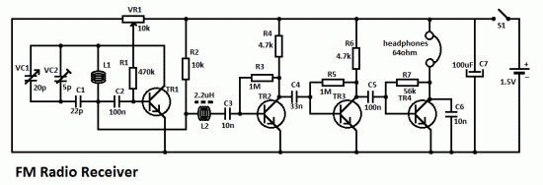
The critical part of the fm radio receiver is the first stage, TR1/VC1, where the wirings must be kept as short as possible. Coil L1 is formed by winding 8 turns of 1mm (20 swg) enamelled copper wire on a 6 mm diameter former, which is then removed. After that L1 should be stretched carefully and evenly to a length of about 13mm.
Transistors List
TR1 = BF199
TR2 = TR3 = TR4 = BC547
The tunning capacitor VC1 is one of the two fm sections of a miniature fm transistor radio with built-in trimmers (VC2). The “earthy” end (moving vanes and spindle) is connected to the 22pF capacitor C1. The value of the rf choke L2 is not critical, anything from 1µH to 10µH being suitable.
The output is suitable for ordinary earphones connected in series to provide an impedance of 64Ω.
Tuning-in the fm radio receiver
To operate the radio receiver, potentiometer VR1 must first be advanced slowly (towards the end of the track connected to battery positive) until, at about the half-way point, a sudden slight increase in background noise will be heard, indicating the onset of oscillation. It then should be backed off, very slowly, until oscillation just stops; it then should be possible to tune in some stations.
The correct frequency range of 87 MHz to 108 MHz can be obtained by adjusting VC2 at the high frequency (108 MHz) and slightly stretching or squeezing together the turns of coil L1 at the end (87 MHz).
Review
Hi everyone, I built this little radio yesterday out of some parts I found in my junkbox and it’s working like a charm. FYI, antenna can be connected to the junction between C1, L1 and C2 (I used 1 meter long telephone wire for the antenna). For TR1 I used BF240 (because that’s the only one I could find in my junkbox that’s suitable for the oscillator/regen. part of the radio). TR1 needs to be suitable for VHF frequency ranges (the FM radio frequency range in particular) otherwise it won’t oscillate/regenerate. As for the quality of reception, this radio can pickup everything the commercial radio can, and quality of the audio received is very good and can be adjusted further with a regeneration control. I also suggest installing the variable capacitor with a plastic knob for changing stations. Because if you use a metal screwdriver on a trimmer capacitor as soon as you tune to some station and when you remove the screwdriver the station is gone, because the screwdriver acts as part of the oscillating circuit and when you remove the screwdriver the frequency changes. So, either use a plastic screwdriver for the trimmer capacitor or use variable capacitor with a plastic knob. As for the headphones, the regular mp3 player headphones/earphones will work just fine. I made couple of photos of it. So, if anyone wants to see what it looks like, ask for the photo and I’ll post it on-line.
This is a perfect project for beginners in RF engineering or amateur radio constructions
Video link
http://www.youtube.com/watch?v=mA0VkAn4XJo

